The carton index screen should show the # of pieces of equipment on the carton

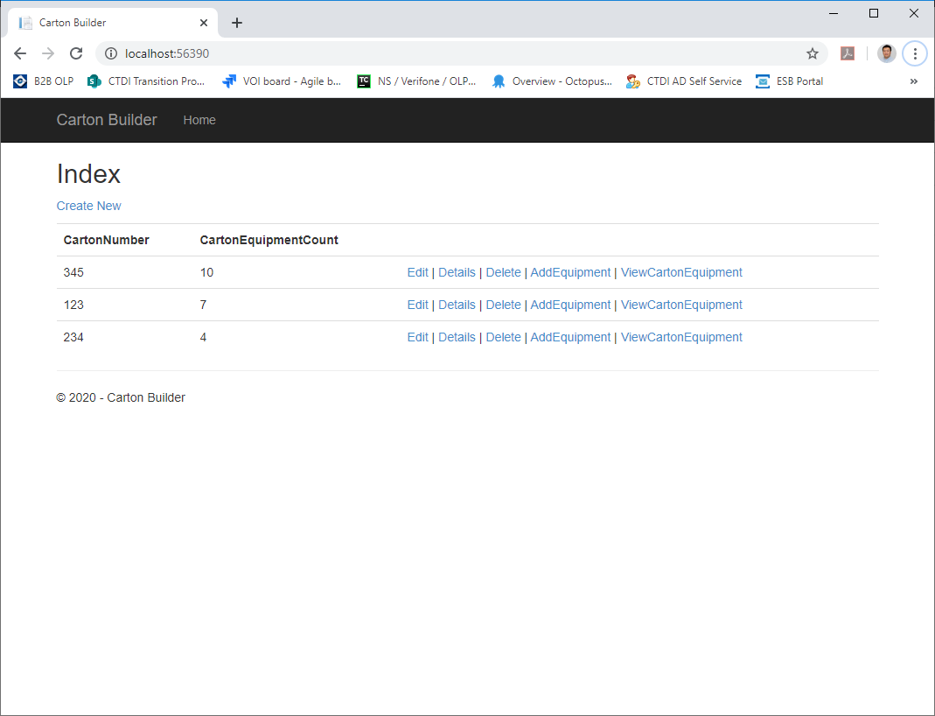

We should be able to delete a carton at any time.

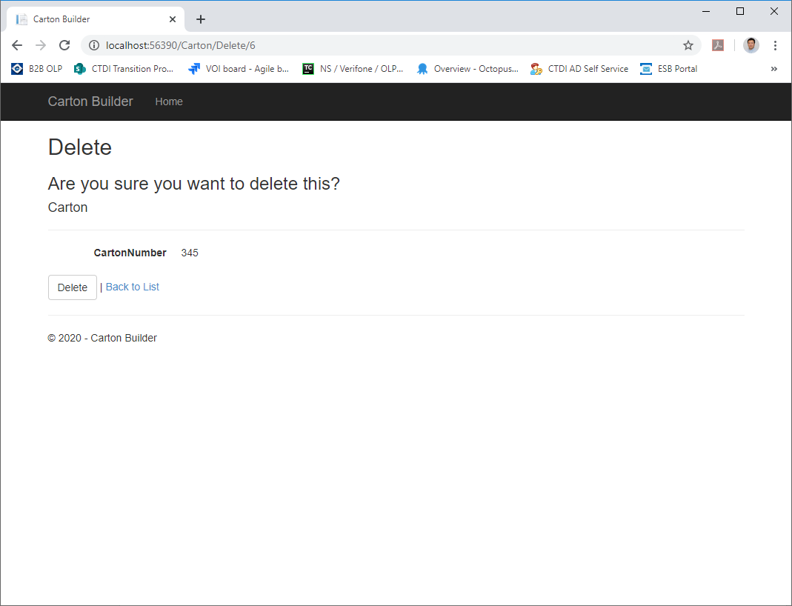

Carton 345 has 10 equipment inside.

Carton that have equipment inside is successfully deleted in next screen.

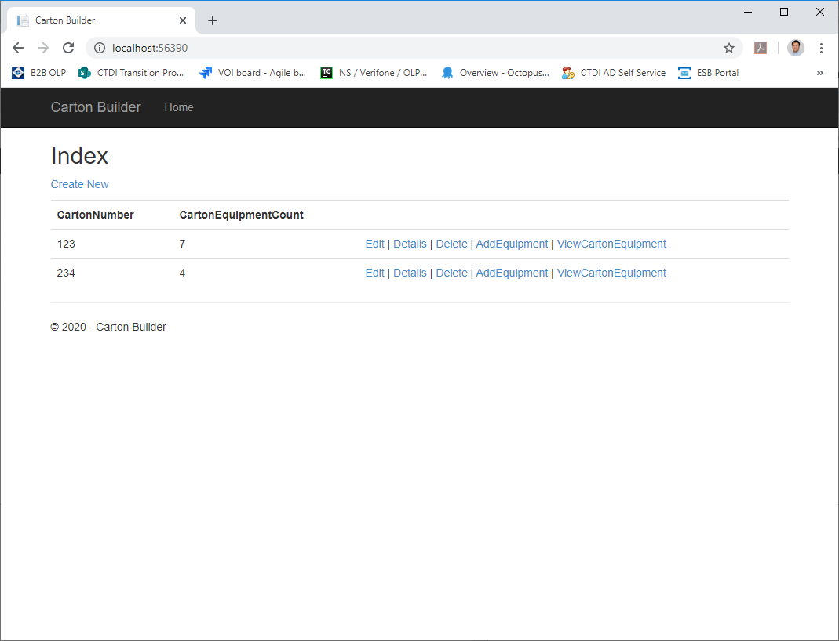

Return error code with message when adding same equipment to different cartons.

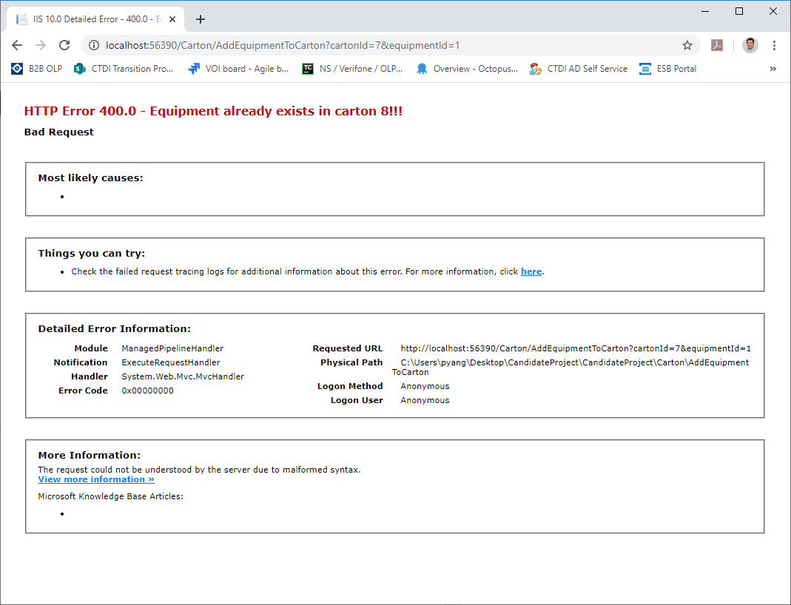

Only allow up to 10 pieces of equipment on the carton.

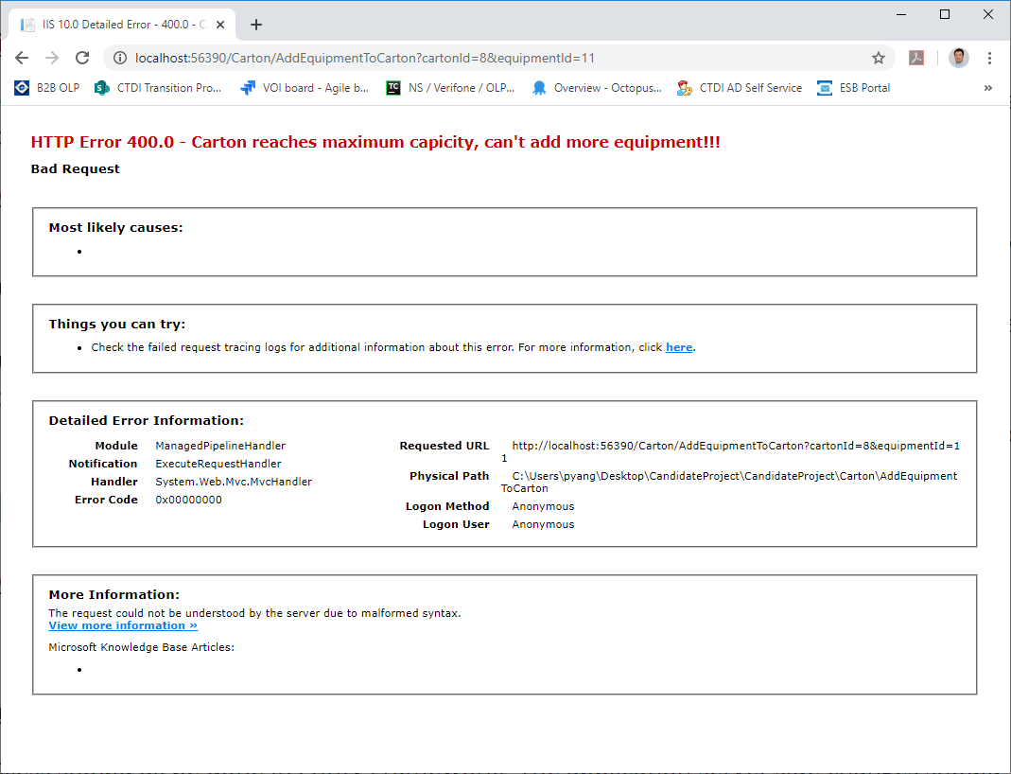

We need a quick way to remove all the items from the carton with 1 click.

